**Challenge 1**

**Improve inaccurate geo-positioning of sharing vehicles due to critical zones of the city.**

A frequent problem with urban sharing services is the lack of geo-positioning accuracy in certain areas of the city. Therefore, the first challenge aims to find solutions to improve the accuracy of positioning systems in order to potentially obtain more accurate data for the Data Marketplace.

**1. Detailed description of the problem**

The following are several practical cases where location accuracy is critical:

1. Precise location of the vehicle parked in an area with trees and high buildings in order to be able to identify the selected vehicle from the rest of those located in the same parking using precise geolocation.
2. Location of the vehicle within a covered parking or underground street where the satellites coverage is partially or totally lost.
3. Limit of service geofence area: be able to allow or reject booking finish function according defined service area.
4. Movement detection of parked vehicle (vehicle parked displacement due to vandalism).

**2. What do we expect as the outcome of the solution?**

Exact position of the vehicle: The client must be able to locate the vehicle with ideally maximum 10 m error (a to c).

**3. What is the scope for changes to the current systems? (software, hardware, etc.)**

Improve the current geolocalization coordinates for the critical use cases described above: ideally only software, but if hardware necessary improvements are identified can be described.

**4. What data are participants allowed to use for the development of their solution?**

Participants are allowed to use telematic trip data extracted from 2 different motorbikes with modified firmware of the SEAT MÓtosharing app. One motorbike uses GPS+GLONASS (*file 4780-LMH.csv*) constellations while the other is using GPS+GALILEO (*file 4846-LMH.csv*) , both doing the same trip at the same time being rode by 2 different riders.

Original planned trip can be found here (take into account that the plan and the reality might not always match):

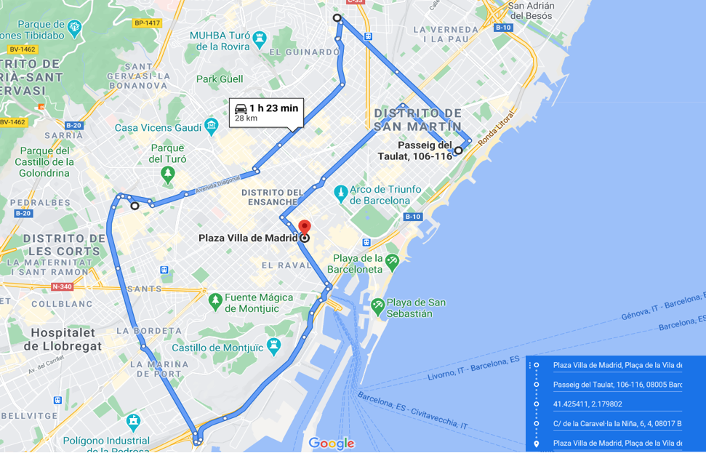

Link: <https://goo.gl/maps/9XHLWLVWxHNyCJWW7>

Also, both vehicles went at some moment through the following coordinates (some areas where location issues have been identified during SEAT MÓtosharing services) during the trip (both at the same time):

· 41.39117799869765, 2.1714383176844594

· 41.402427855338836, 2.2095850408065036

· 41.42629607668137, 2.178534728729327

· 41.39707927096545, 2.1610984060893346

· 41.38991293556385, 2.134182994705349

**5. Evaluation process of the final solution**

Teams will be evaluated based on a final presentation on the two following outputs:

- Geolocalization error improvement compared to current status available in SEAT MÓtosharing.

- Difficulty and cost of implementation of the improvement.